Abstract— This Project deals with the Industrial Embedded Automation for a milk exporting industry (Chilling Plant) using NI ELVIS II Prototyping board with the help of LabVIEW Software. The different sensor networks are settled or placed at a different places of milk processing areas in industry. By making them into a bunch of connection and they connected to NI ELVIS II Board. And by ELVIS board to the PC (Personal Computer). In PC, the LabVIEW Software is installed for the extracting the information that coming from ELVIS Board through USB port of PC. LabVIEW will show in a graphical manner or with some 3D animated format. This information will be displayed on the PC window as a notification. So, operator can respond quickly.

**INDUSTRIAL AUTOMTATION AND MONITORING USING LabVIEW SOFTWARE FOR MILK DAIRY**

B.M.R. Manasa*, J. Sai Pavan, Anyam Mohan

Department of E.C.E, Sreenivasa Institute of Technology and Management Studies, Chittoor, Andhra Pradesh, India.

Email*: [anyammohan332@gmail.com](mailto:anyammohan332@gmail.com)

Keywords— **LabVIEW, NI ELVIS II series, milk industry, embedded project on LabVIEW, ELVIS board**

1. INTRODUCTION

The process of milk started at the milk weighing bowl (used to note the weight of milk in litres). And it passed to the dump tank (used to store the milk for 2 to 3 minutes). After collecting some 500 to 800 litres in dump tank the chiller motor will be switched ON in order to chill the milk by decreasing its temperature to 2°C from the 30°C. The chiller having mainly 4 to 5 ports. In which port1 is connected to dump tank, port 2 is connected to the IBT water tank as water IN, port 3 is connected to the storage tank 1, port 4 is connected to the IBT water tank as water OUT. The water in IBT water tank need to be at below 2°C because of maintaining the milk at 2°C. So, Another Cooling Control Mechanism is maintained with ammonia storage tank, compressor, condenser. The ammonia gas is in liquid form in the storage tank by producing gas. The ammonia gas has a property that it absorbs the heat at neighbour areas. The gas is converted into a low-pressure low-density vapor and it flow through the IBT tank Coils which are fixed as S-shaped in water. So, the water gets cooled by the Gas. The Compressor will take the low-pressure & low-density vapor and compresses into high-pressure & high-density vapor which is having high temperature.

However, it needs to be low temperature. So, the condenser coils are used.

In this the S-Shaped vapor flow valves will be there. The continuous water is dropping is happening at condenser coils. So, the vapor gets into certain room temperature and that gas is filled in the ammonia tank. Again, it will go to the IBT. In this way a Closed Loop Controlling will be performed up to the milk gets into 2°C.

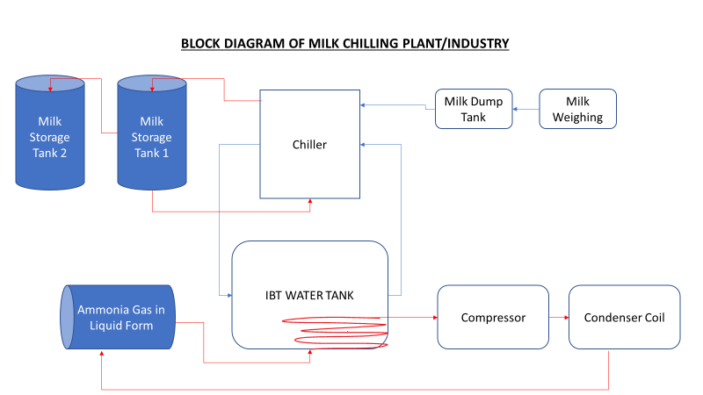

Fig: Circuit diagram of milk chilling plant

The level monitoring and temperature controlling of milk and water is done by our project which keep the milk at 2°C at all time.

1. LITERATURE SURVEY

Mohammed Zahid, Gharpure D. C” Smart Home using LabVIEW (DAQ-6009) presented that Home automation is done easily with LabVIEW and DAQ systems. Here we taken LabVIEW with DAQ (NI ELVIS series II). The Industrial Automation is done at present with DCS (Distributed Control System) or CCS (Centralised Control System) or Arduino uno. But each one having Some disadvantages. And these are seenable at large scale industries only because of its cost. In this, Automation & Research and Development becomes very easy. ELVIS Board have Hardware Features and LabVIEW has Software Features and it runs on highly upgraded processor in which it is installed. So, it will give high speed which is not there in Arduino uno based Automations.

1. PROPOSED METHOD

An automation with combination of National Instruments NI ELVIS II prototyping board and LabVIEW software is designed for the milk industry with low cost but with effective tools. We use NI ELVIS II prototyping board as a CCS (Centralized Control System). It will take the information from a greater number of Sensors like temperature sensor LM35 and ultrasonic sensor SR-04. A single software (LABVIEW Software) is used, which have multiple options to decorate as per the industry needs. All about our project neatly explained below.

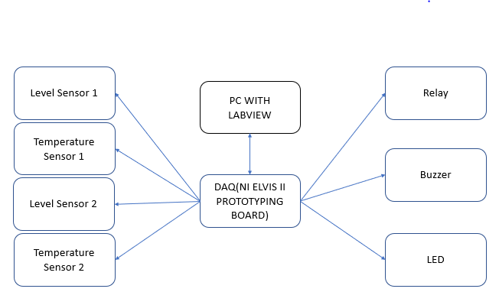

Fig: Block diagram of proposed system

**Components used:** The hardware components are lised below,

1. NI ElVIS II prototyping board
2. LM 35 temperature senosor
3. SR-04 ultrasonic sensor
4. Buzzer
5. Relay
6. LED

Software components are listed below,

1. LabVIEW 2019 version
2. NI ELVISmx instrument launcher.

**Intialization :** Before to start connection procedure we need to Intialize the setup of some components as desribed below.

Intall the LabVIEW 2019 in laptop or Personal Computer by visiting ni.com. There we we can download either online setup or offline setup. Install the NI ELVIS Instrument launcher by searching it on the same website ni.com. as it need a liscene to activate the LabVIEW 2019 we need to download the “ni liscene deactivator ” from the web and activate all liscences with it, that’s all the setup.

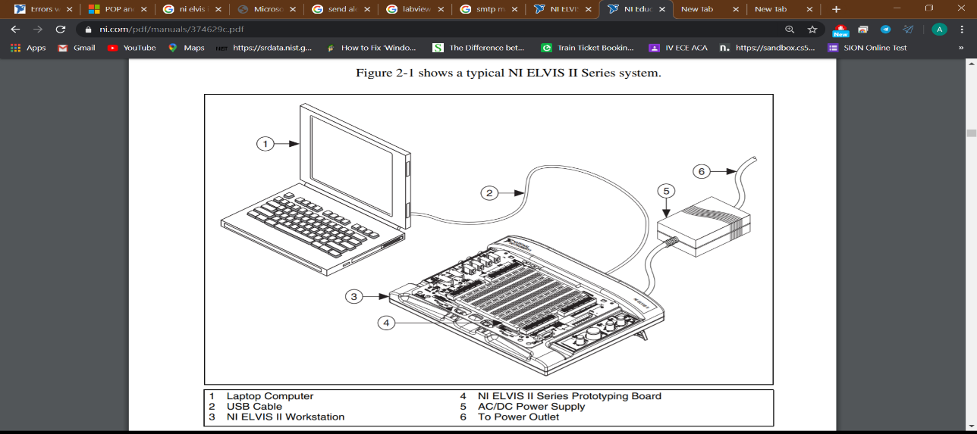

Fig: Intial setup for operator

On coming to Connection Setup of the bench to operate

* The NI ELVIS board is connected to laptop or personal computer by using a USB cable.
* The LM 35 and SR-04 senors are connected to the prototyping board.
* On by opening the LabVIEW software front and block diagram pannel is taken side by side.

**LabVIEW :**  Jeff Kodosky cofounded NI in 1976.Laboratory Virtual Instrument Engineering Workbench(LabVIEW) is a system-design platform and development environment for a visual programming language from National Instruments. The graphical language is named "G“.

It consist mainly 2 sections.

1.Front Panel

2.Block Diagram panel

**Front Pannel :** The Front panel is the user interface of a VI. In this only indicators like numerical or graphical will present as shown in figure.

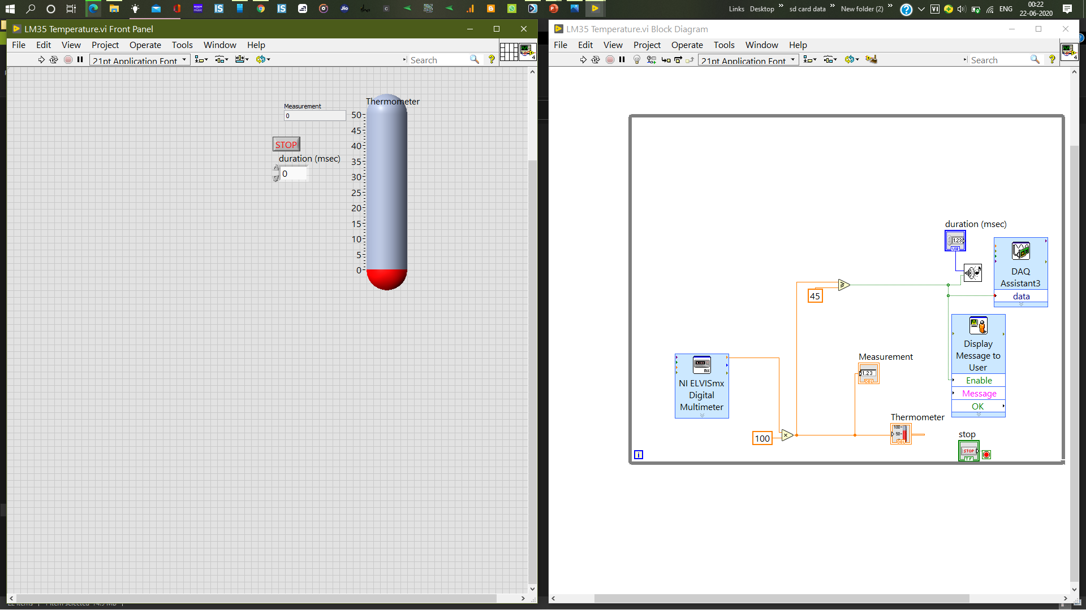

Fig: Front pannel

**Block Diagram:**  The block diagram contains the graphical source code of a LabVIEW program. Front panel objects appear as terminals on the block diagram.

When you create or open a new VI, the front panel opens automatically. To bring up the block diagram, select Window»Show Block Diagram from the menu bar. Additionally, you can toggle between the block diagram and the front panel by pressing <Ctrl-E> .

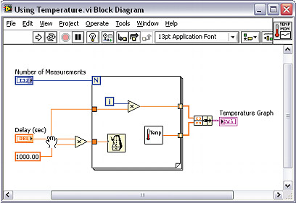

Fig: Block diagram panel

**NI ELVIS series II:**  The NI ELVIS (National Instruments Educational Laboratory Virtual Instrumentation Suite II Series) combines Hardware and Software into One Complete Laboratory Suite. We can connect the PC to these various measurements through USB plug-and-play capabilities and build circuits on a detachable protoboard.

NI ELVISmx is the software that supports NI ELVIS II Series hardware. It provides the following LabVIEW soft front panels (SFPs):

* Arbitrary Waveform Generator (ARB)
* Bode Analyzer
* Digital Reader
* Digital Writer
* Digital Multimeter (DMM)
* Dynamic Signal Analyzer (DSA)
* Function Generator (FGEN)
* Impedance Analyzer
* Oscilloscope
* Two-Wire Current Voltage Analyzer
* Three-Wire Current Voltage Analyzer
* Variable Power Supplies

The board look like,

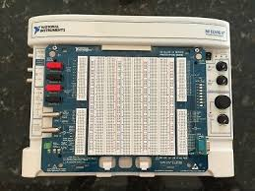

Fig: NI ELVIS prototyping board

**VI Creation:**  VI stands for Virtual Instruments and Creation means need to create a VI with your creativity as you want. But here we create an VI for the milk industry to get automatically detect the temperature and level and maintain milk at 2°C temperature at all time.

The VI starts with the function palate which is appear on either front panel or block diagram panel on right clicking the mouse, it is seen as below.

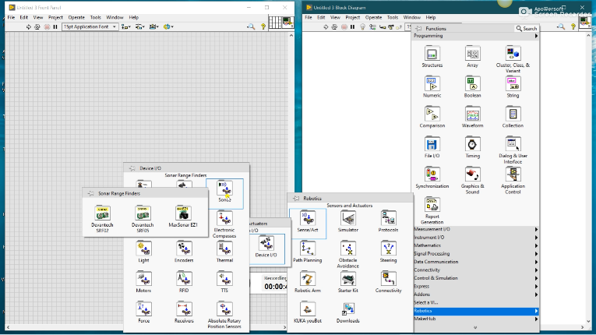

Fig: Function palate

So, here we are doing the level checking on milk with SR-04 ultrasonic sensor. So, as per our need we can add an add-on driver to the function palate from the NI store at ni.com. From there we install a robotics module and Deventech SRF-05 driver to concatenate with SR-04 ultrasonic sensor because the functioning is same and off course the work fine and smooth. After this we make an VI with the help of

* Deventech SRF-05 driver
* Robotics module
* One while loop with stop button
* NI ELVISmx variable power supply
* Indicator in distance in cm

The complete VI of level sensing is shown in below picture:

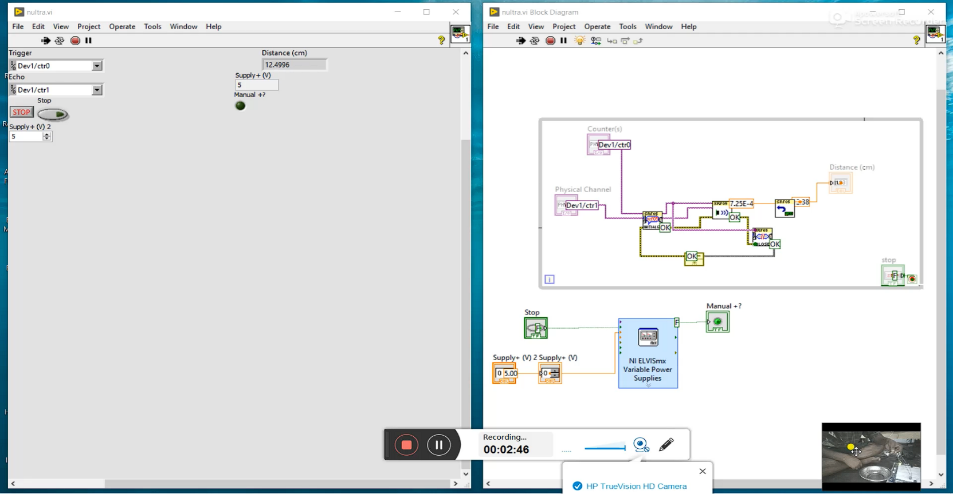

Fig: VI for level sensing

The other creation is also need to create for the sensing the temperature of the milk and the water. For this VI we use these things

* NI ELVISmx digital multimeter
* Thermometer graphical indicator
* Measurement in digital indicator
* DAQ assistant as OUT
* Beep sound function
* While loop with stop button
* DC input with NI instrument launcher
* Timer to beep sound

On creation of data in the block diagram automatically the respective indicator will be added in the front panel. So, here we show only the VI picture of block diagram panel only. The complete VI of Temperature sensor is shown in below picture:

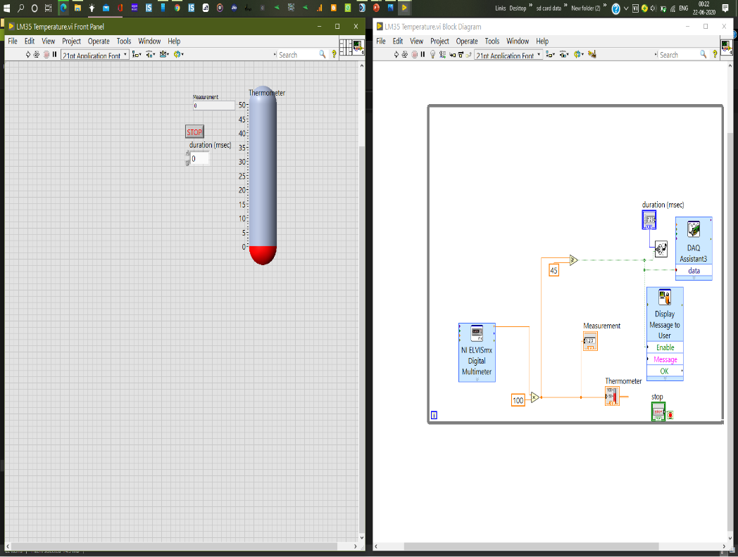

Fig: VI for temperature sensing

Here we set 45°C as a threshold value to get triggered with room temperature on heating. But if we provide a condition that temperature is below 2°C then we can modify the threshold value from 45°C to 2°C by changing value at the 45 in block diagram as 2, that’s it.

**Pin to pin Connection:**  To work this VI we need to give proper pin to pin connection from the sensor components to the NI ELVIS prototyping board. If it is not done perfectly output will not get as perfect.

* The SR-04 has 4 pins named as ground, vcc, trigger and echo.
  + Ground pin of sensor to gnd pin of prototyping board.
  + Vcc of senor to the varial power supply positive pin.
  + Trigger of sensor to ctr0 out (counter out).
  + Echo of sensor to ctr1 gate (counter gate).
* Next in the picture is LM 35. It has 3 pins name as ground, vcc, data out.
  + Ground pin of sensor to gnd pin of prototyping board.
  + Vcc of sensor to the A0 pin and on creation of DC voltage on Instrumen launcher the output is set to the A0 pin.
  + Data out of sensor is connected to the digital multimeter probes of prototyping board.
* Relay is connected at the AI0 of the prototyping board.
* Buzzer is also connected to the AI0 of the prototyping board.
* LED is also connected to the AIO of the prototyping board.

1. RESULTS

**Results:**  The results of the each output is neatly showned below one by one.

* The output of the level sensor when it placed far away from the water is shown below:

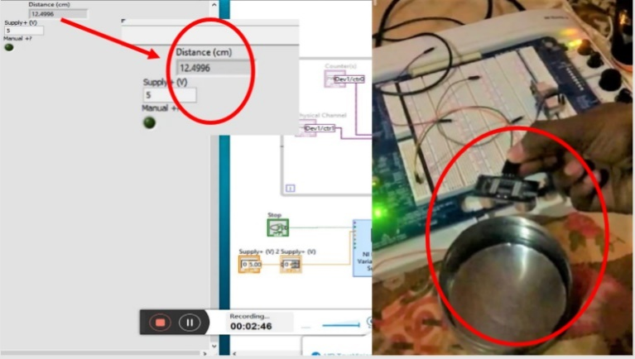

Fig: Output of level sensor

* The output of the level sensor when it placed nearer to the water level is shown below:

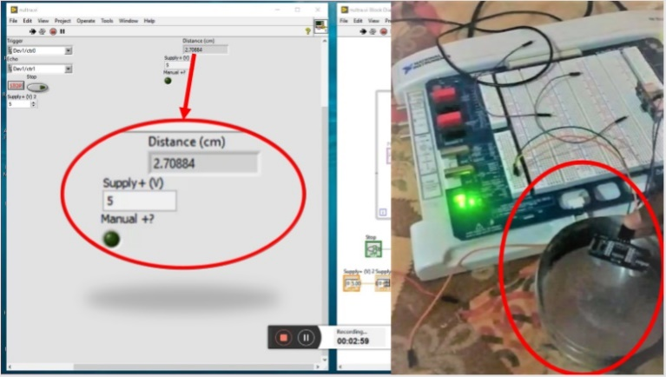

Fig: Output of level sensor

* The output of temperature senore when it is heated more than 45C is shown below:

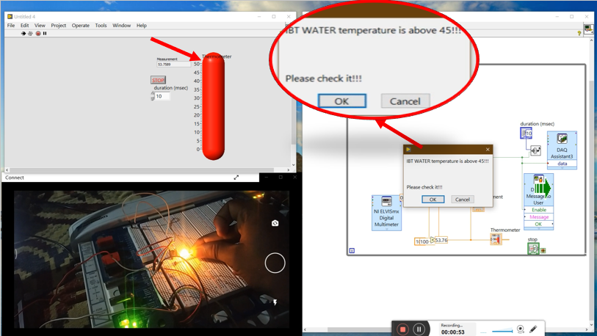

Fig: Output of temperature sensor

* The output of temperature sensor when it is cooldown or at less than 45°C

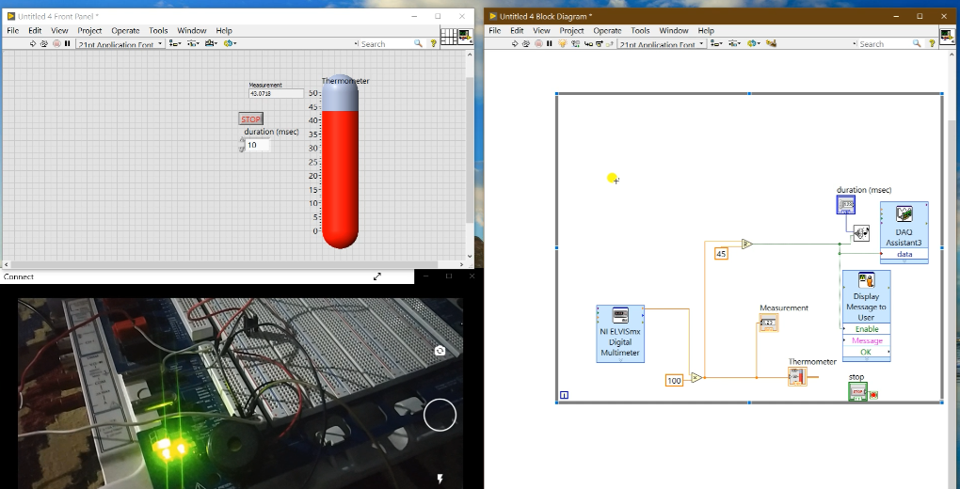

Fig: Output of tempertaure sensor

V.CONCLUSION

An low priced Automation Control system is developed for the Small Scale Milk Industry by our team. So with this Monitoring & Controlling make very easy by sitting from on place with one operator in PC which will reduces lot of work and Money And Maintenance. Not by building big control system with high costs but there is need to built small control system for small industries with low price. LabVIEW is successfully linked with NI ELVIS II board. By Adding some more sensor networks with the upgraded Nation Instruments Boards by Using LABVIEW software will Give lot of effort less industrial automations.

The NI(National Instruments) Provides Various Researchable new Devices which will be suitable for future scope. And LABVIEW Software gives super Graphical 3D Outputs which can liked by all in feature and also right now because it is needed. So This NI Based LABVIEW Automation will be reference model to the other futurely come NI based LABVIEW Automations.

References

1. Mohammed Zahid, Gharpure D. C” Smart Home using LabVIEW (DAQ-6009)” The paper of NSPTS National Seminar On Physics and Technology of Sensors.
2. Basil Hamid “Design and implementation of smart house control using LabVIEW”. International Journal of Soft Computing and Engineering volume1, issue6, January 2012.
3. Dr.A.J.Patil, Rajesh Khare, Mahjesh Patel “Real Time System development For home Automation Using LabVIEW” International Research Of Advanced Development in Electrical, Electronics and Instrumentation Engineering” vol.2, Issue 4, April2013.
4. S. Nithya, Abhay Singh Gour, Model Based Controller Design for Shell and Tube Heat Exchanger, Sensors and Transducers Journal, Vol. 84, Issue 10, pp.1677-1686, Modeling and Control of Temperature Process using Genetic Algorithm, International Journal of Advanced Research in Electrical, Electronics and Instrumentation Engineering. Vol.2, Issue 11, November 2013.
5. "Introduction to the Arduino Microcontroller, " Hands-on Research in Complex Systems, June 17 –29, 2012. Sabedin A. Meha, Besnik Haziri, Loreta N. Gashi, “Controlling DC motor speed using PWM from C# Windows application”, 15th International Research and Expert Conference, "Trends in the Development of Machinery and Associated Technology” TMT 2011, Prague, Czech Republic, September 2011.